

Application Form

ALAN JAMES CREATIVE BURSARY AND RESIDENCY 2024-25

Access
Please let us know if you have any communication access requirements that we should be aware of during the application process eg you wish a PA to be copied into communications.

Your contact details
Name(s):

Postal address:

Email address:

Phone number:

Website and social media links:

Links to music/videos:
Please note that applications will not be considered without this.

Under which of the following categories do you wish your application to be considered?

Global majority artist led project Yes/No
Disabled artist led project Yes/No
Residency at The Glasshouse International, Gateshead Yes/No
Residency at Cecil Sharp House, London Yes/No

It may be appropriate for you to be considered in more than one category eg a global majority artist led project which would prefer to work at The Glasshouse International or a project being led by artists who are both global majority and Disabled or an applicant that is happy to be based at either Cecil Sharp House or The Glasshouse International.

About You
Please provide a brief CV for all the artists involved.

What do you want to do?
Please outline the creative idea you wish the Bursary to support.
(500 words max)

How would the Bursary support benefit your creative development?
(200 words max)

What are you hoping to do with the R & D in the future?
(200 words max)

Proposed Timetable
Please note that we may not be able to accommodate your precise dates at Cecil Sharp House or Glasshouse International so flexibility will be very helpful.

Proposed Budget
The bursary will cover £2000 of expenditure and there is further funding offered to Disabled Artists for Access costs eg a personal assistant, BSL interpreter, transport.

Expenditure
Artists’ fees:

Travel costs:

Accommodation costs:

Other expenses (please identify)

Access costs (only applicable to Disabled artists):

Income
If you budget exceeds £2000 (excluding access costs), please identify where the additional funding will come from eg other grants, donations, own funds – and if these funds are confirmed or unconfirmed.

FURTHER INFORMATION

Payment
The bursary will be paid in two instalments: 80% of the grant will be paid on receipt of the signed offer letter; the balance will be paid on submission of a report (1 side A4) which will be required within one week of completion of the project and no later than 31 March 2025.

Dates and submission details
The deadline for completed applications is Tuesday 2 July 2024, at midnight; applications should be sent to Zoe Nicol, Artistic Programme Co-ordinator, zoe@efdss.org
Applicants will be informed of the outcome by Friday 2 August 2024.
All projects must be completed by 31 March 2025.
Equal Opportunities Form - please complete the online Equal Opportunities form for monitoring purposes (not used in the assessment of your application)

Partners Organisations
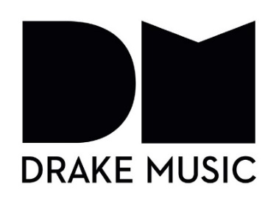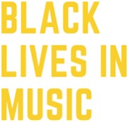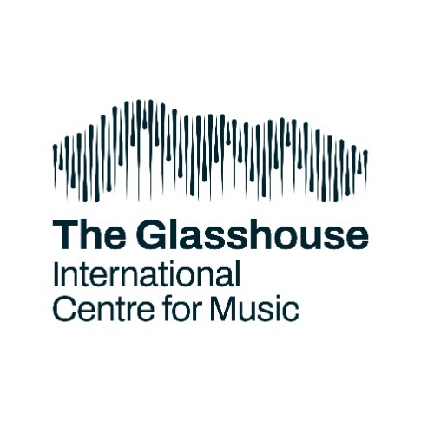

Funders
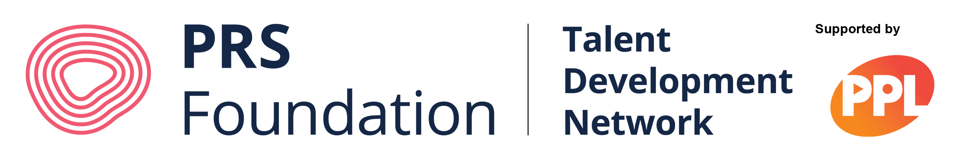

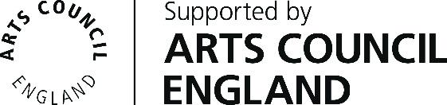

English Folk Dance and Song Society, 2 Regent’s Park Road, London, NW1 7AY
020 7485 2206 : www.efdss.org
Registered Charity 305999; Company Limited by Guarantee 297142;
VAT No. 233 8664 49

